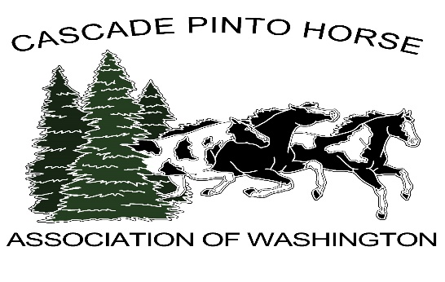
CASCADE PINTO BACK NUMBER
RESERVED FORM FOR
2020 SHOW SEASON
NAME: _____________________________________ EMAIL:________________________________________
PHONE:___________________________HORSE REG. NAME:________________________________________
- Reserved Back Numbers are first come first serve.
- Numbers are $10.00 for the Cascade Pinto Show Season and remain with the Horse.
- You can select any number.
- You will receive one set of (2) of your number for the show season, you must request this at least 10 days before the show.
- You must renew your previous back number by April 1, 2020 or your old number will be released if not Paid in Full prior to April 1, 2020
1ST Choice___________________ 2nd Choice_________________ 3rd Choice_______________

Shows that this applies for are:
All Cascade Pinto Shows 2020 May, July Dual Show, Oct

Mail this form and Full Payment for 10.00 for each set of numbers.
Make Checks out to: Cascade Pinto
Mail To: Wendy Davidson C/O Cascade Pinto
21404 161ST AVE SE
Monroe, WA 98272

